**Azure Virtual Machines**

There are 3major delivery models when it comes to Cloud services. They are:

1. **SAAS – Software as a Service**
2. **PAAS – Platform as a Service**
3. **IAAS - Infrastructure as a Service**

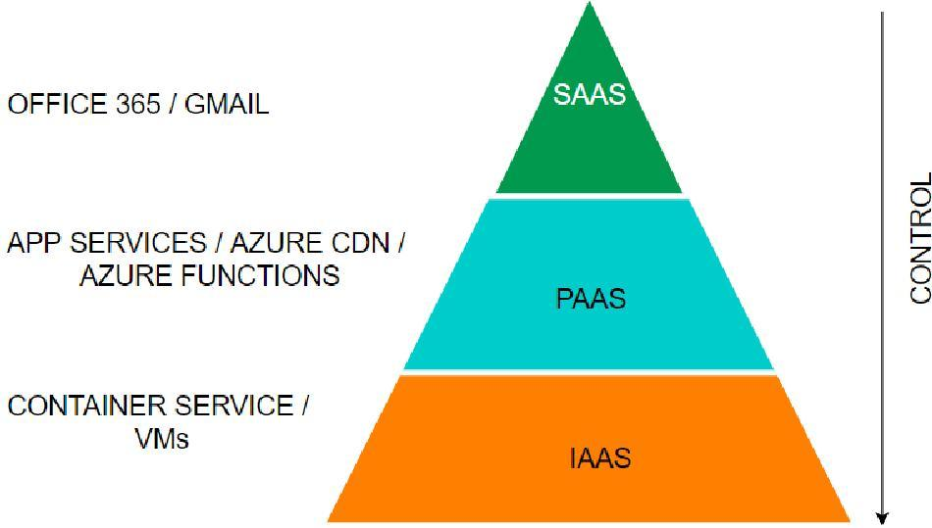

* Azure Virtual Machines are part of the **IAAS** offering from Azure.
* As customers, we are responsble for managing the virtual machine, and just the hardware will be provided to us by the cloud provider. We can *start, stop and delete* the virtual machine.
* If we find that the capacity is insufficient or too high, we can change to a different machine type. We can install any software as we like.
* Also, please note that this is the most expensv e of the three offerings.
* We can create **Windows or Linux VMs**, and there are multipleloc ations throughout the world where resources can run from.
* When we create a VM, we need to attach a virtual hard disk, and the location that we specify is where the hard disks are stored.

***Here is the SLA table:***

| **SI No.** | **VM** | **Disk** | **SLA** |
| --- | --- | --- | --- |
| 1 | 2or mor e VMs across 2or mor e AZs |  | 9.9% at least 1VM |
| 2 | 2or mor e VMs in a same Availability set |  | 9.95% at least 1VM |
| 3 | Single VM | Premium or Ultra disk for all disks | 9.9% |
| 4 | Single VM | Standard SSD | 9.5% |
| 5 | Single VM | Standard HDD | 95% |

***Please see below details for VM types:***

| **Sl No** | **Type** | **Sizes** | **Short Description** | **Best for** |
| --- | --- | --- | --- | --- |
| 1 | GP  (General Purpose) | B, Dsv, Dasv, Dav, Av2, DC , Dsv | Balanced CPU to memory | Testing/ Dev, small DB, low traffic servers |
| 2 | Compute Optimized | F, Fs, Fsv2 | High CPU to memory | Medium traffic servers, batch processes, ap servers |
| 3 | Memory- Optimized | Esv, Ev, Eav, Mv2,  M, DSv2, Dv2 | High memory to CPU ratio | RDBMS servers |
| 4 | Storage Optimized | Lsv2 | High disk throughputand IO | Big data/ DB warehousing/ Large DB |
| 5 | GPU | NC, NCv2, ND , NV | Specialized VMs for heavy graphics | Model training with deep learning |
| 6 | HPC(High-perf ormance Compute) | HB, HBv2, HC , H | Fastest and most op werful CPU | Real-time processing |

**FAQs**

1. **How do I resize a VM?**

* You can first run the list-vm-resize-options and see available sizes. If you find the size, you can run the resize command
* az vm resize --resource-group WLRG --name WLVM1 --size Standard_DS3_2
* Else you need to deallocate the VM, which will allow you to use any size. You need to deallocate, resize and start a VM.

az vm deallocate --resource-group WLRG --name WLVM1

az vm resize --resource-group WLRG --name WLVM1 --size Standard_DS3_2

az vm start --resource-group WLRG --name WLVM1

1. **What are Azure Dedicated hosts?**

* We usually shared the physical hardware with other tenants. If we want exclusively to use the physical server, then we can choose dedicated hosts.

1. **What are Azure Spot instances?**

* This feature allows us to take advantage of the unused CPU at a significantly lower cost at almost 0%9 savings.
* If there are workloads that can tolerate disruption and can be restarted, then we can choose this option.
* If there is another bidder who bids more than our price, we will be vacated on 30 seconds’ notice. So we need to be prepared with proper scripts to save the data or any other process from exiting gracefully.

4 **How can we save costs on VMs other than Spotins tances?**

* There are two other ways we can save on costs.–
  + **Reserved Instances** – We can commit to -1 year or 3- year and choose to pay upfront or monthly to buy RIs. We have the flexibility to change size if needed.
  + **Azure Hybrid Benefit** – If you have a license already, you can use the license on Azure and get this benefit.

1. **What are Azure Images?**

* If there is a custom image that we want every VM to have when created, we can choose to create a standard VM and syspr ep and then create an image. We can then use this image to create VMs.

1. **How can we make VMs highly available?**

* We had discussed in the excel above with SLAs. We can use multiplemachines either in availability or in more than 1 availability zone.
* In addition to this, we can use Azure VMSS (Virtual machine scale sets).
* VMSS is automatically created from a central configuration using a standard template.
* More VMs will be added during peak and will be brought down when the demand goes down based on our auto-scaling options.

1. **How can we back up VMs?**

We have 3 options:

1. **Azure Backup** – We can create recovery vaults and configure Azure Backupt o backup ourVMs
2. **ASR (Azure Site Recovery)** – Here, our VMs are replicated to another region, and our entire production region fails; we can failover to the backupareas with the click of a button
3. **Managed Snapshots** – If we have managed disks, we can take a snapshot of our disks, a read-only copy. We leveraged this feature for quickback ups in dev and test environments.

0.1 **How can we monitor VMs?**

* Under Monitoring tabs, we have metrics to see various parameters. We can also set alerts. We can also Log analytics by enabling the Logs option in Monitoring. We need to create a log analytics workspace.

**Azure AppService**

* Azure AppService allows us to run aplications on the cloud. Here are some features:
  + HTTP based Service for hosting web aplications, REST APIs, and mobile backends.
  + Suports NET , .NET Core, Java, Ruby, Node.js, PHP, Python
  + Run and Scale on Windows/Linux
* *Ap Services run under a pa service plan.*
* *A pa service plan is the logical abstraction that represents one or more VMs that runs the pa service. It consists of compute resources like CPU, memory and disk space.*
* *We pay for pa service plans and not the pa service.*
* *Also, we can have more than one pa service running inside an pa service plan. The number of pa services that can run inside an pa service plan depends on the pa service plan. Also, the amount of resources like CPU, RAM and disk space depends on the paservice plan.*

| **Plan** | **Comput e typeDomain** | **Custom** | **Scaling** | **Workload** |  | **SpaceBackup**  **/ Restore** | **No of Ap s (max)** |
| --- | --- | --- | --- | --- | --- | --- | --- |
| Free | Shared | No | No |  | Nil | No | 010 |
| Shared | Shared | Yes | Yes | Dev |  | 1GBNo | 01 |
| Basic | Dedicated | Yes | Yes | Dev/Test | 10GBNo |  | Unlimited |
| Premium | Dedicated | Yes | Yes | Prod | 0G25 B | Yes | Unlimited |
| Isolated | Isolated | Yes | Yes | Prod |  | 1TBYes | Unlimited |

*Let's look at some features of Apservices:*

| **Deployment Slots** | This concept is used for zero downtime deployments. There will be a production slot and a Staging slot. New version of the Production deployment will be done in the Staging slot. Either all at once deployment or in stages(canary) will be done. |
| --- | --- |
| **Deployment Center** | This allows for Continuous integration/ Continuous deployment (CI / C D ) |
| **Custom Domains** | By default, the website will be [xxxx.azurewebsites.net](http://xxxx.azurewebsites.net). We can buy a domain in your company name and use that name. |
| **SSL Settings** | You can certificates and ensure encrypted data transmission between client and Server |
| **Scale up (ApService**  **Plan)** | You can increase the size of your VM if you need more resources |
| **Scale out (Ap Ser vice Plan)** | You can also increase the number of instances. You can either do this manually with a slider or set uprules/ schedule to scale automatically on schedule or CPU usage (like >70%) |

**FAQs**

1 **How does app service plan work?**

* App service plan is supported by Service Fabric.
* Service fabric replacesinstances if an existing one fails. Also, it adds instances if there is a requirement.

**2. What are the typesof Ap Services?**

There are 4typesof services as follows:

| **Sl no** | **Type** | **Purpose** |
| --- | --- | --- |
| 1 | *WebAp (previously Azure*  *Websites)* | Hosting websites and web aplications |
| 2 | *API Ap* | Used for hosting the RESTful APIs |
| 3 | *Logic Ap* | Used for business process automation, system integration and sharing data across clouds |
| 4 | *Mobile Ap (previously delivered*  *b y Azure Mobile services)* | Used for hosting mobile app back ends |

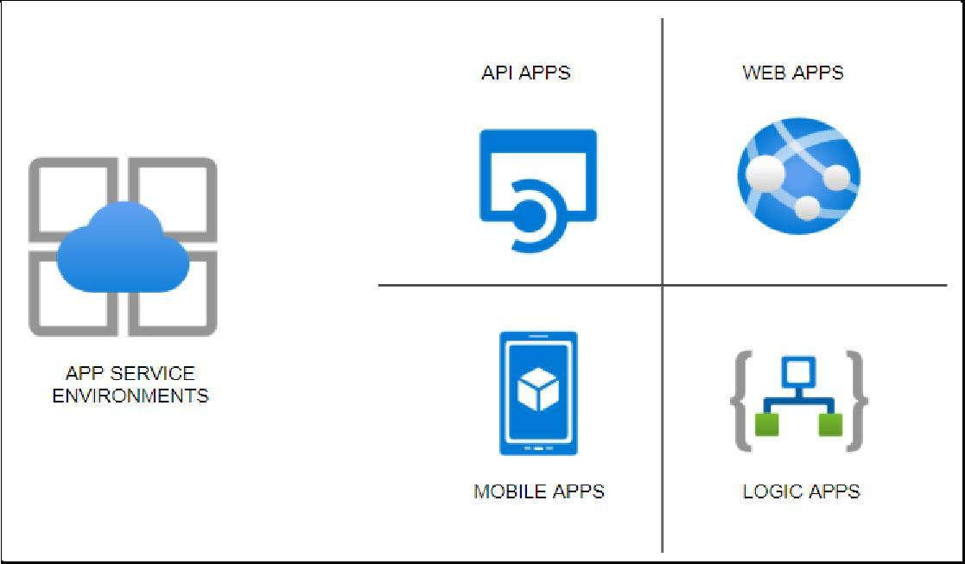

**App Service**

* HTTP based Service for hosting web aplications, REST APIs, and mobile backends.
* Suports NET , .NET Core, Java, Ruby, Node.js, PHP, Python
* Run and Scale on Windows/Linux

**Features**

* **PAAS** – Patches/OS Maintenance done by Azure ●
* Suport for Containerization and Docker
* Serverless
* **Deployments Slots** – Swapaplication content in Prod and avoid downtimes
* Grouped under ApService plans with following tiers

●

| **Plan** | **Compute type** | **Custom Domain** | **Scaling** | **Workload** | **Space** | **Backup/ Restore** | **Others** |
| --- | --- | --- | --- | --- | --- | --- | --- |
| Free | Shared | No | N o |  | N il | N o |  |
| Shared | Shared | Yes | Yes | Dev | G1 B | N o |  |
| Basic | Dedicated | Yes | Yes | Dev/Test | 0G1 B | N o |  |
| Premium | Dedicated | Yes | Yes | Prod | 0G25 B | Yes |  |
| Isolated | Isolated | Yes | Yes | Prod | 1TBYes |  | Private Endpoints |

**App Service types**

* **Webapps** – Websites/Online Ap s
* **Webapps for Containers** – Containerization
* **API apps** – backend data

*Can add – V net Integration /Hybrid Connections/Security , but these are not asked in the exams.*

**Tips**

* When you move an Apservice from one RG to another, the App Service plan doesn’t change.
* Destination RG cannot contain ApSer vice resources like Web apor ApService
  + plan.
* **.Net** Core aplication can be deployed on Windows or Linux OS
* **ASP .Net** app CANNOT be deployed on Linux OS. Only Windows OS
* Multiple Web Apps can be hosted on a single ApService plan.
* Web Ap and Ap Service plansmust exist in the same region.

**Aplication Service Environments**

* There are 3 components for hosting *web pa s/ Docker containers/ Mobile pa s* and functions. There are apservice plans which host the spservices.
* When we host the regular app services, the apps are directly exposed to the internet, and the resources are shared.
* Some organizations prefer to host the services in the internal network, and security features like firewalls and security groups could be aplied t o protect the apps.
* For such scenarios, there is a feature called the **Azure App Service Environment**, which provides a fully isolated and dedicated environment for securely running App Service apps at a high scale.
* **Ap Service environments (ASEs)** provide very high scaling with isolation and secure network access with high memory utilization.
* We can create multiple ASEs within a single Azure region or across multiple Azure regions, making it ideal for horizontally scaling stateless application tiers when we have high **requests per second** (**RPS**) workloads.
  + There are three types of workloads available when choosing the workload tier. They are *Dev/test, Production, and Isolated.*
* Of these, the isolated offering provides the ASE environments which host applications within the client’s VNets. As stated, we have fine-grained control over inbound and outbound application network traffic.
* While the other category of app services has a fixed suffix of [azurewebsties.net](http://azurewebsties.net), we can create our own domain name.
* Also, ASEs come with op werful computers, which is twice as op werful as the regular app service plans. They also come with **1TB** Storage as compared to **50GB** of space for the regular ones.
* We can host up to 01 instances which are sufficient to host a miniature web service hub. We can expect the service to cost us about **250-30$** per month, which is very cheapf or the services being provided.

**Steps to creating App Service Environment**

* In the first screen, we select if the service is public-facing or internal
* Then we select whether we are hosting Windows-based or Linux-based OS.
* On the second screen, we select the Vnet where we want to host the service. *(Since*
  + *services are being created in our private infrastructure, it takes much longer time to*
  + *create)*
* ● Then we can DNS resolution. We can create our own private zone and use that name. This is not possible when choosing the other ap service plans

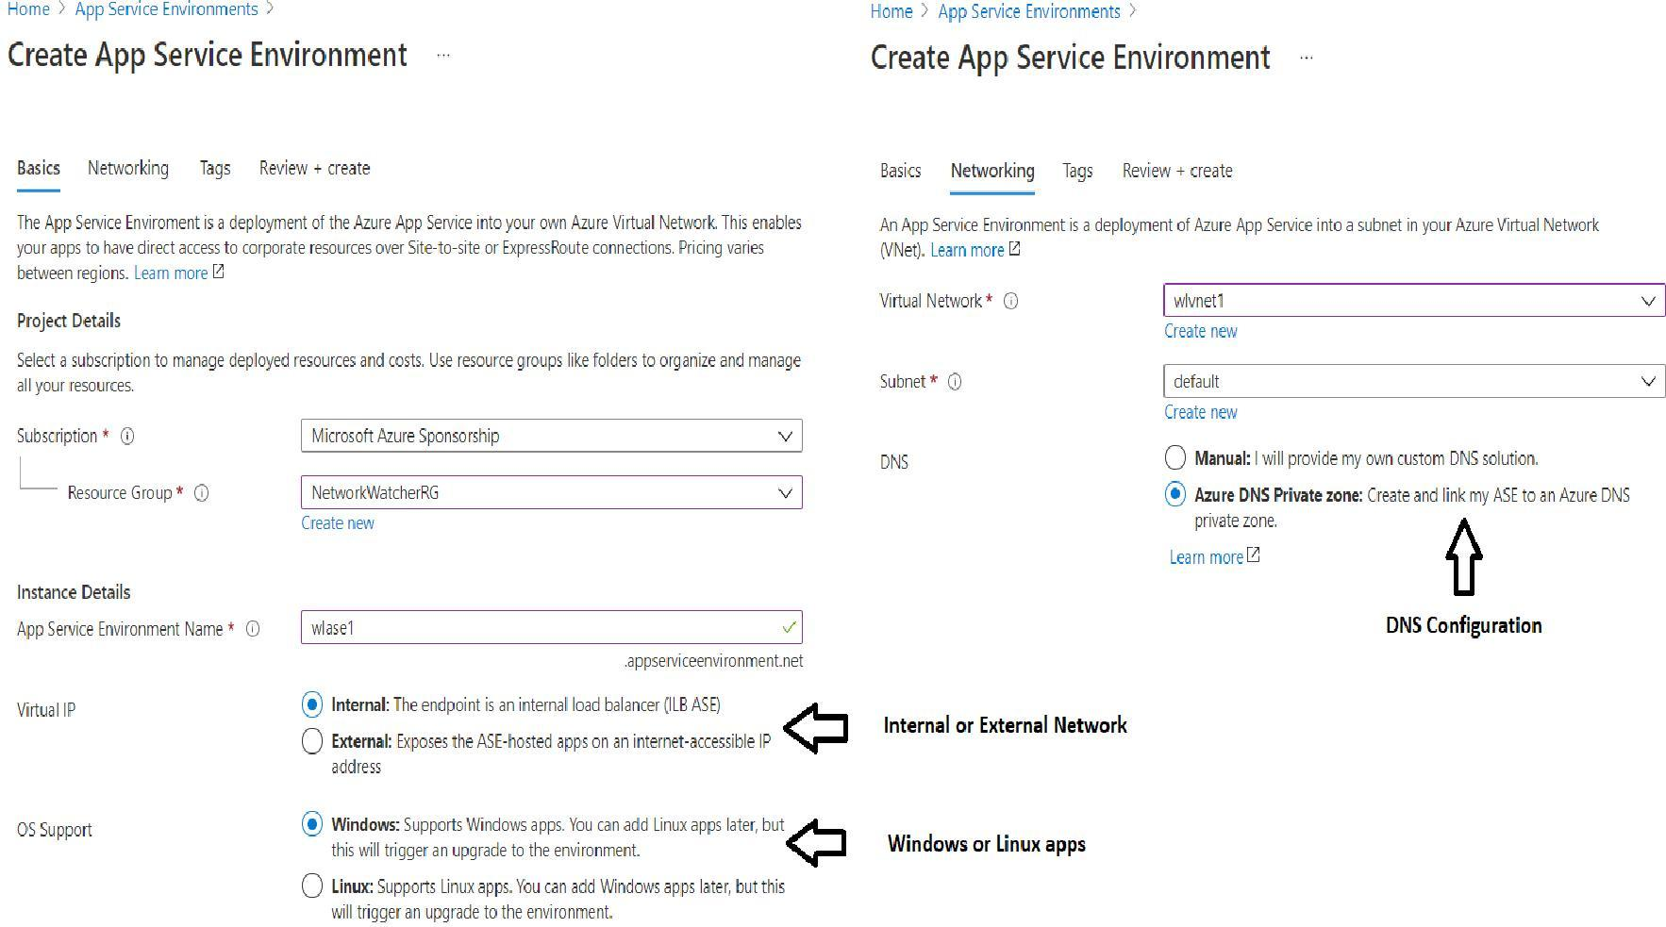



**Steps to creating Web Apps under ASE**

* Please note that the process is similar except that we dropdown the region and select the ASE which we just created.
* Also, the below screen shows various features under ASE and pricing under each of the pricing tier s I1and I2 and I3. 13.

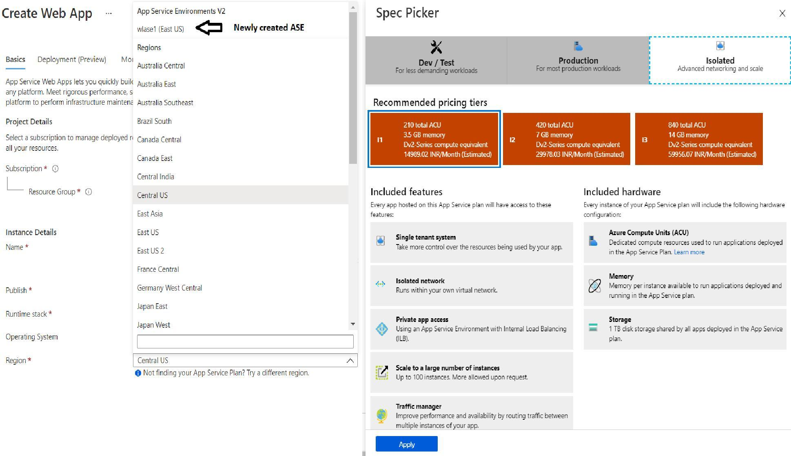

***Note:*** *The Private link vnetLink (wlase1.ap*[*serviceenvironment.net/vnetLink)*](http://serviceenvironment.net/vnetLink)) *is also created below. You can go to the Resource group and click on “Show hidden types'' to see this resource.*

***Note:*** *Please see the Ap Service plan as I1:1 in the screenshot below to identify the isolated service plan.*

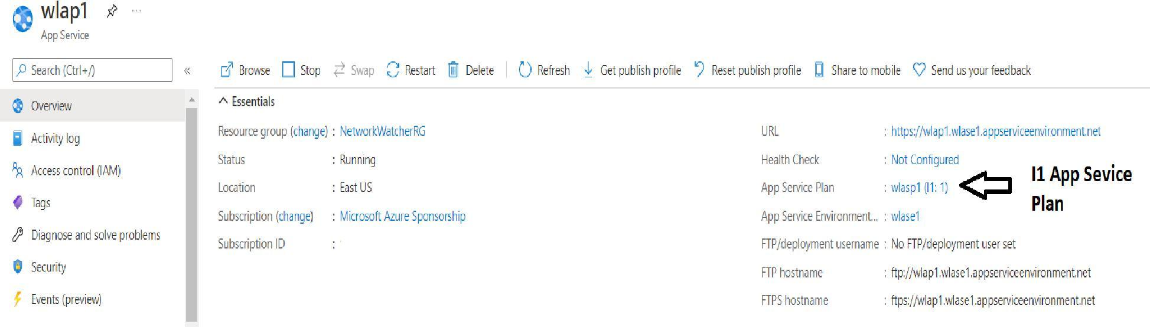

**Azure Container Registry**

**What is a Container Registry?**

* A Container Registry is a central repository to store and distribute container images. A container image includes all the data needed to start a container - **for example** , the operating system, libraries, runtime environments, and the application itself.
* We first build an image, and then we push the image to the repository. When needed, we pull the image into the target environment. With versioning as a feature, we have multiple versions of the container, and the different versions like the stable version would be used for Production.
* Versions being tested would be in non-pr oduction regions. In the example below, v2 is a stable version, and the developer makes changes and creates v3. Once v3 is tested, it would be then pulledin to Production.

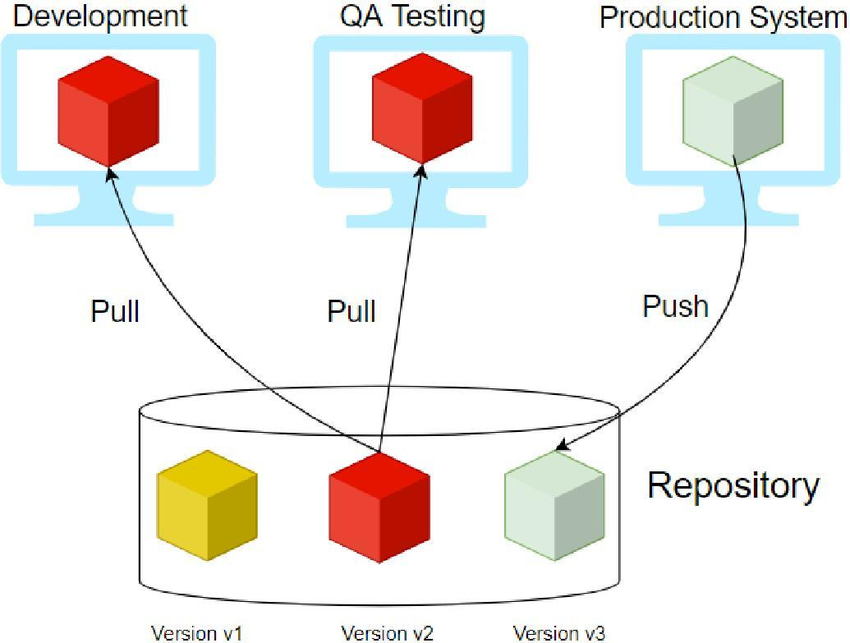

**Providers**

Few providers provide the container registry services, and they are:

* **Docker Hub**
* **Azure ACR (Azure Container Registry)**
* **AWS ECR (Elastic Container Registry)**
* **Github Container Registry**
* **Google Container Registry**

|  | **Amazon ECR** | **Docker Hub** | **GitHub Container Registry** | **Azure Container Registry ( ACR)** |
| --- | --- | --- | --- | --- |
| **Public Repository** | No | YES | YES | No |
| **Private Repository** | Yes | YES | YES | Yes |

| **Pricing (Public Repository)** |  | $0 | $0 | $0 |
| --- | --- | --- | --- | --- |
| **Pricing (Private Repository)** | $ | $ | $ |  |
| Storage: $0.10 per  GB, Data Transfer: $0.09 per GB | >= $7 peuser/month | Storage: $0.25  perperGB, Outgoing Data Transfer: $0.50  perGB | Storage: $0.09  perGB |
| **Authentication** | AWS IAM | Password or Access Token | Personal Access Token (PAT) | PAT |
| **MFA for Image Push/Pull** | Yes | NO | NO | NO |
| **SLA Availability** | 9.9% | N/A | N/A | 9.9% |
| **General Available** | YES | YES | Beta | YES |
| **Immutable Images** | YES | NO | NO | YES |
| **Image Scanning** | YES | YES (paid plans  only) | NO | YES |
| **Regions** | Choose between one of 52regions worldwide | Not Known | Not Known | 3regions |
| **Rate Limits** | Pull: 1,0  persec ond, Push: 01 per second | Pull: /0102  ( FreePlan), unlimited (Paid Plan) | n/a | Pull: 1,0per  second, Push: 01 per second |

**ACR Service Tiers**

ACR is available in 3ser vice tiers, also called SKUs.

1. **Basic** – Cost Optimized for developer s
2. **Standard** – All features of Basic plus increased storage and image throughput. For Production
3. **Premium** – highest amount of storage and concurrent operations. It also includes geo-replication, content trust, and private link

**ACR Roles**

| **Role/Permission** | **Create/Delete ACR** | **Push** | **Pull** | **Signature Signing** |
| --- | --- | --- | --- | --- |
| *Owner* | X | X | X |  |
| *Contributor* | X | X | X |  |
| *Reader* |  |  | X |  |
| *AcrPush* |  | X | X |  |
| *AcrPull* |  |  | X |  |
| *AcrImageSigner* |  |  |  | X |

-

**FAQs**

* **Can we change Service tiers - YES**
* **What is geo-replication?** 
  + With this feature, a replica of the ACR will be created for DR purposes and local use.
* **How can we secure the images in ACR?**
  + There is a concept called CONTENT TRUST. With this, images will be signed with certificates.
  + To enable this feature, enable registry content trust.
  + It is available under **Policies ->Content Trust ->Enabled and then save.**

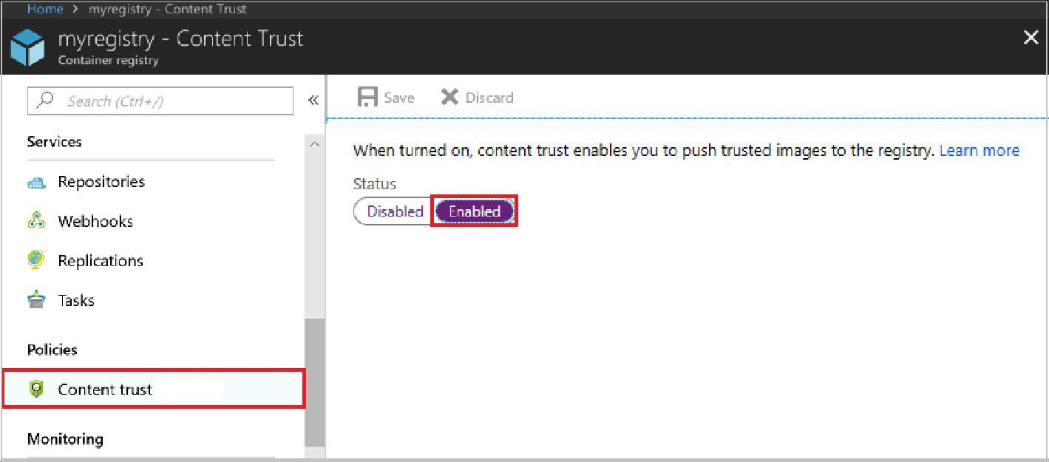

**Azure Container Instance (ACI)**

* Containerization is the buzzword today. Instead of spinning Physical servers and installing all the dependencies, and installing the application, we can create a container containing all the required dependencies.
* We then package and create an image and deploy it into a container.
* **Docker** is one of the platforms where we can run these containers in the Open source world. Azure has two solutions. One of those is the ACI.
* ACI is a great solution in scenarios where we need to run isolated containers. Examples are simple aplications, task automation, and build jobs.
* The drawback of ACI is that it cannot be used for full orchestration like multiple containers, auto-scaling, and coordinated application upgrades. Please consider AKS for such scenarios, which is the other offering from Azure.
* In simple terms, for Production, use **AKS (Azure Kubernetes Service)**, and for simple and isolated containers, use ACI.
* One of the other best use cases for ACI is where we have production issues, and we need to troubleshoot AKS, ACI comes to our rescue where we deploy the trouble-making container in ACI and try to debug.

**Advantages of ACI**

* *Fast Startup Startuptimes*
* *Container access*
* *Custom Sizes*
* *Persistent Storage* – We do this by mounting Azure file shares.
* *VirtualNe twork deployment* – When deployed in a Vnet, ACI can securely communicate with other resources in the Vnet.

**FAQs**

1. **What are probes in ACI?**

o You can configure the liveness probe. We check the liveness probe to see if the container is healthy. If the container is not healthy, we need to restart. There are common scenarios when containers run for a long time.

o You can configure the readiness probe. Here we might have a scenario where the container (maybe DB for the backend) is just coming up. We run the readiness probe and send requests to the container only if the probe succeeds.

1. **How can we monitor ACI?**

* We use Azure Monitor. Here are the available metrics at this time.
* CPU Usage measured in millicuries (One millicore is 1/10th of a CPU core)
* o Memory Usage in bytes
* o Network bytes received persec ond.
* o Network bytes transmitted persec ond

**What are container groups?**

* Similar to AKS for orchestration, we can use container groups to combine and manage containers. They get scheduled on the same host machine.
* The concept is similar to pods in Kubernetes. The use case for this is in scenarios where we want to divide a single functional task into a smaller number of container images. An examplei a front-end container and a back-end container.
* The front end might serve a web application, with the back end running a service to retrieve data.

**Azure Kubernetes Service ( AKS)**

**What is Containerization?**

* In the traditional computing system, we had to install an Operating system and install all dependencies for an application to work. Only a single OS could be installed.
* Then came Virtualization where we could install multiple OS by introducing another layer between the hardware and the OS and this was called Virtualization. So only physical machines apear ed as multiples ystems.
* Then came a lightweight alternative to virtualization, which was called Containerization. This removed the drawback of having a full machine, and this had only the necessary components.
* Containers will encapsulate an application with its operating system. This would contain all the dependencies that were needed for an application to run. So we take the container and run it on any operating system, and it will run.
* Some of the containerization options are Docker, which is the most popularand
  + sometimes equated to containers. But there are others like **LXC/LXD, ContainerD, Rocket**.

**Orchestration**

* Orchestration is the system that is used to manage the deployment of containers. We use Orchestrators as tools to achieve this. Some of the performed activities are automating the maintenance of those applications, replacng failed containers automatically, and managing the rollout of updates and reconfigurations of those containers during their lifecycle.
* The popular tools are
  + *Docker Swarm by Docker,*
  + *Nomad by Hashicorp,*
  + *Flocker, and*
  + *Kubernetes by Google.*
* Kubernetes, also stylized as K8s, is an open-source container orchestration system. It is used for automating comput er aplic ation deployment, scaling, and management.
* It was originally designed by Google and influenced by Google’s Borg System and is now maintained by the Cloud Native Computing Foundation. It is a cluster management software for Docker containers mainly but suports others also.

**AKS**

Kubernetes has become very popular , and many cloud service providers offer a Kubernetes-based platform or infrastructure as a *PaS or IaS offering.*

*Google has GKE (Google Kuberne tes Engine),   
AWS has EKS (Elastic Kuberne tes Service), and   
Azure has AKS (Azure Kuberne tes Service)*

**Components of AKS**

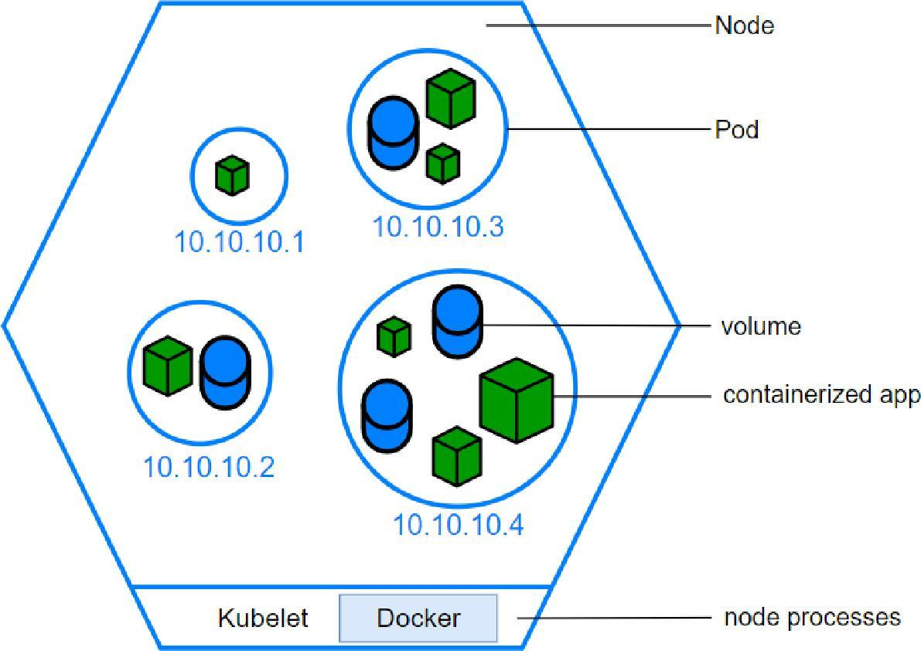

**1 . The Cluster**

o The Cluster contains 2c omponen ts

▪ Control Plane – this consists of kube-apiser ver, etcd, kube-scheduler and kube-controller-manager

▪ Nodes that run the applications

**2 . Persistent Volumes**

o Since the nodes are added and removed on-demand and the storage associated with it is temporary, we need to create storage outside of the cluster. Hence we create persistent volumes.

**3 . Node**

* We create Node pools in Kubernetes (as shown below). Here we choose a VM size, and that will be the unit size of the nodes within the pool.
* We can add node pools as needed. The first node poolcreated is the **system node** pool which hosts critical system podslk e coreDNS and tunnel front.
* We then add user node pools for aplic ation suportand create different pools based on theaplication requirements.
* Pods will be created within the nodes, and the max pod setting is configured at the node pool level.

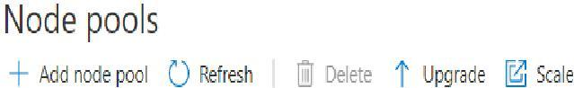

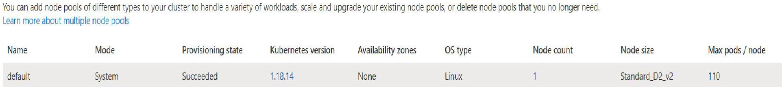

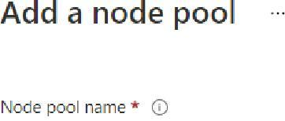

**4 . Containers**

* We store our code that is going to be run inside containers. There are readily available pr e-built containers stored in container repositories or we can create our own containers.
* One or more programs can be run from the containers

**5. Pods**

* Nodes create Pods, and kubernetes use Pods to run instances.
* Usually, only one container is run within a pod, but multiple containers could run in a pod if there was a requirement from the application.
* We scale based on pods. When we can scale, we simply use pod replicas.
* A new pod will be spun up in another node, and we now have an additional pod.
* Sameway, we can remove the pods to scale down.

**6 . Deployments**

o We don’t launch podsdir ectly. Instead, we create deployments.

o A deployment will state how many replicas should run and the system manages that.

**7 . Ingress**

o By default, Kubernetes provides isolation between pods and the outside world. If you want to communicate with the service running in the pods, you need to open the communication. This is called Ingress.

o You can achieve this communication in several ways. The most common ways are Ingress controller or a load balancer. Please see the sample service.yaml file which creates an external load balancer. We get the IP of this service and connect.